SilverScreen

Use-Case: Add Movie

Version 1.0

Revision History

|  |  |  |  |
| --- | --- | --- | --- |
| **Date** | **Version** | **Description** | **Author** |
| 22.11.2016 | 1.0 | Initial draft | Fabian Blatz |
|  |  |  |  |
|  |  |  |  |
|  |  |  |  |

Table of Contents

[1. Use-Case Name 4](#_Toc465673097)

[1.1 Brief Description 4](#_Toc465673098)

[2. Flow of Events 4](#_Toc465673099)

[2.1 Basic Flow 4](#_Toc465673100)

[2.2 Alternative Flows 4](#_Toc465673101)

[3. Special Requirements 4](#_Toc465673102)

[4. Preconditions 4](#_Toc465673103)

[5. Postconditions 4](#_Toc465673104)

[6. Extension Points 4](#_Toc465673105)

Use-Case Specification: Add Movie

# Use-Case Name

## Brief Description

The User enters a form where he can search for movies he already watched and enjoyed and add them to his collection. The corresponding movie-ID from TmDB will be saved to the Database and associated to the user.

## MockUp

## C:\Users\Simon\Desktop\Like_Movie_Mockup.png

# Flow of Events

## Basic Flow



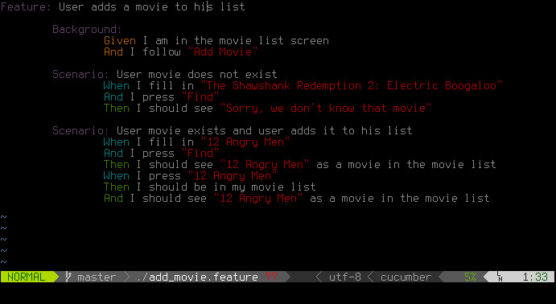

## Alternative Flows

#### None

# Special Requirements

The phone has an active internet connection

# Preconditions

The user has an activated account and is logged in.

# Postconditions

The MovieID is associated with the username in the Database

# Extension Points

None